# Lab 3: Styles Using CSS

## Objectives

*  Install CSS
*  Apply CSS

## Steps

### Install CSS

### ****Open**** a ****new**** command prompt (Windows) or terminal (Mac) ****window****.

! Be sure to open a new window. Leave npm start running.

1. Run one of the following commands:

npm install mini.css@3.0.1

Warnings can be ignored but Errors indicate there was a problem.

1. Verify mini.css was added as a dependency of the project in package.json.

#### \package.json

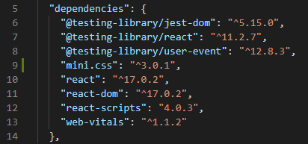

### Apply CSS

1. **Open** and **delete** the contents of app.css
2. Open the file App.js.
3. Delete the JSX returned and replace with the HTML as shown below.

#### src\App.js

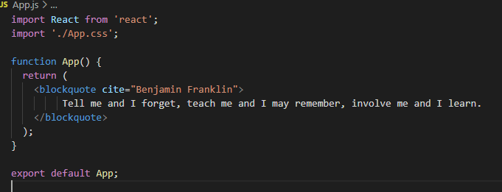

1. Open the file src\index.css
2. Delete the current contents of the file.
3. Import the stylesheet you installed.

#### src\index.css

@import '../node_modules/mini.css/dist/mini-default.min.css';

Alternatively, you could choose a dark theme: mini-dark.min.css or a nordic theme: mini-nord.min.css

1. Verify you see the following output in the browser

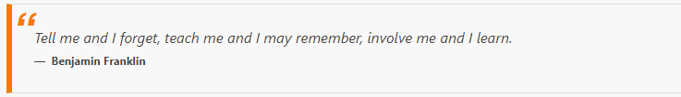

[Mini.css](https://minicss.org/" \t "https://handsonreact.com/docs/labs/js/_blank) is a **minimal**, responsive, style-agnostic **CSS framework**. Mini.css is similar to Bootstrap but lighter and **requires fewer CSS classes** so you can **focus** on learning React but still get a **professional look**.

### ✔ You have completed Lab 3[#](https://handsonreact.com/docs/labs/js/03-StylesUsingCSS" \l "-you-have-completed-lab-3" \o "Direct link to heading)